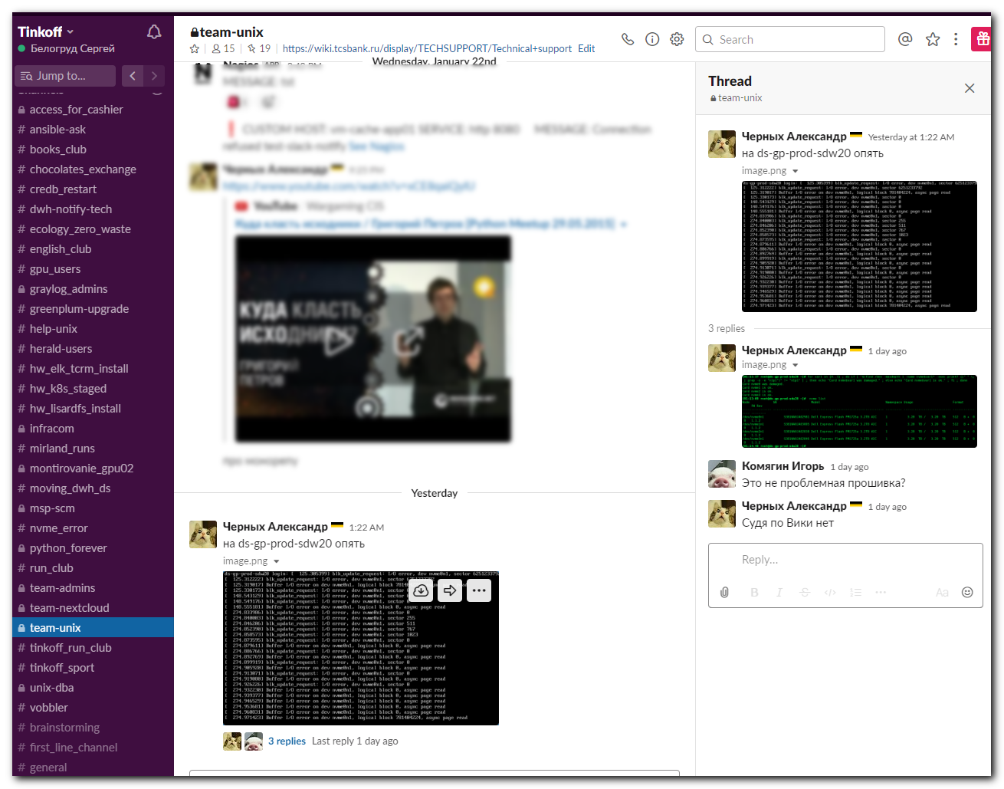
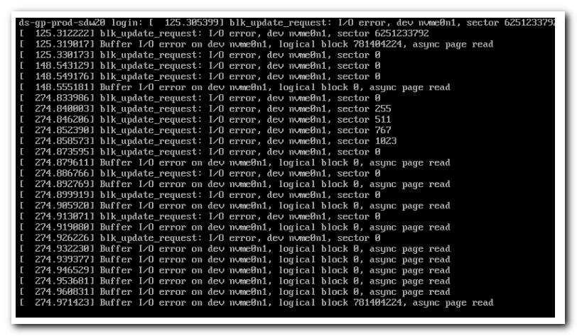

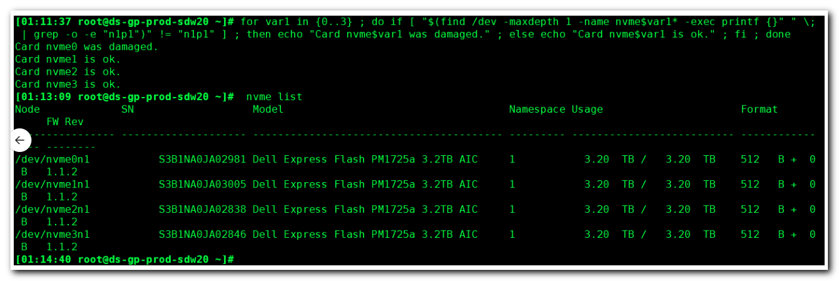

#
# This way is much faster.
# See what nvme is absent if we know, that there are four nvme cards, installed, on server.
#
[14:44:59 root@ds-gp-prod-sdw20 ~]# ls /dev/nvme[0-9]
/dev/nvme0 /dev/nvme1 /dev/nvme2 /dev/nvme3
[14:50:44 root@ds-gp-prod-sdw20 ~]#

[14:52:26 root@ds-gp-prod-sdw20 ~]# lsblk /dev/nvme[0-9]n1
NAME MAJ:MIN RM SIZE RO TYPE MOUNTPOINT
nvme0n1 259:4 0 2.9T 0 disk
└─nvme0n1p1 259:7 0 2.9T 0 part /data1
nvme1n1 259:0 0 2.9T 0 disk
└─nvme1n1p1 259:1 0 2.9T 0 part /data2
nvme2n1 259:3 0 2.9T 0 disk
└─nvme2n1p1 259:6 0 2.9T 0 part /data3
nvme3n1 259:2 0 2.9T 0 disk
└─nvme3n1p1 259:5 0 2.9T 0 part /data4
[14:52:42 root@ds-gp-prod-sdw20 ~]#

[12:44:11 root@ds-gp-prod-sdw20 ~]# ls -Alh /dev/nvme*
crw------- 1 root root 242, 0 Jan 26 01:05 /dev/nvme0
brw-rw---- 1 root disk 259, 4 Jan 26 01:19 /dev/nvme0n1
brw-rw---- 1 root disk 259, 7 Jan 26 01:20 /dev/nvme0n1p1
crw------- 1 root root 242, 1 Jan 26 01:05 /dev/nvme1
brw-rw---- 1 root disk 259, 0 Jan 26 01:05 /dev/nvme1n1
brw-rw---- 1 root disk 259, 1 Jan 26 01:05 /dev/nvme1n1p1
crw------- 1 root root 242, 2 Jan 26 01:05 /dev/nvme2
brw-rw---- 1 root disk 259, 3 Jan 26 01:05 /dev/nvme2n1
brw-rw---- 1 root disk 259, 6 Jan 26 01:05 /dev/nvme2n1p1
crw------- 1 root root 242, 3 Jan 26 01:05 /dev/nvme3
brw-rw---- 1 root disk 259, 2 Jan 26 01:05 /dev/nvme3n1
brw-rw---- 1 root disk 259, 5 Jan 26 01:05 /dev/nvme3n1p1
[12:44:23 root@ds-gp-prod-sdw20 ~]# lsblk
NAME MAJ:MIN RM SIZE RO TYPE MOUNTPOINT
sda 8:0 0 744.6G 0 disk
├─sda1 8:1 0 200M 0 part /boot/efi
├─sda2 8:2 0 1G 0 part /boot
└─sda3 8:3 0 743.4G 0 part
├─rootvg-root 253:0 0 150G 0 lvm /
├─rootvg-swap 253:1 0 16G 0 lvm [SWAP]
├─rootvg-opt 253:2 0 50G 0 lvm /opt
├─rootvg-var 253:3 0 100G 0 lvm /var
└─rootvg-tmp 253:4 0 8G 0 lvm /tmp
nvme0n1 259:4 0 2.9T 0 disk
└─nvme0n1p1 259:7 0 2.9T 0 part /data1
nvme1n1 259:0 0 2.9T 0 disk
└─nvme1n1p1 259:1 0 2.9T 0 part /data2
nvme2n1 259:3 0 2.9T 0 disk
└─nvme2n1p1 259:6 0 2.9T 0 part /data3
nvme3n1 259:2 0 2.9T 0 disk
└─nvme3n1p1 259:5 0 2.9T 0 part /data4
[12:44:37 root@ds-gp-prod-sdw20 ~]#

